5.60: a) The tension in the cord must be 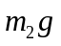 in order that the hanging block move at constant speed. This tension must overcome friction and the component of the gravitational force along the incline, so 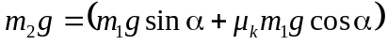 and 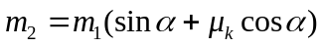.
b) In this case, the friction force acts in the same direction as the tension on the block of mass , so 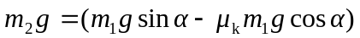, or 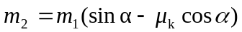.
c) Similar to the analysis of parts (a) and (b), the largest 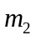 could be is 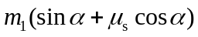 and the smallest could be is 

